**Market Analysis in Banking Domain**

1. Load data and create a Spark data frame

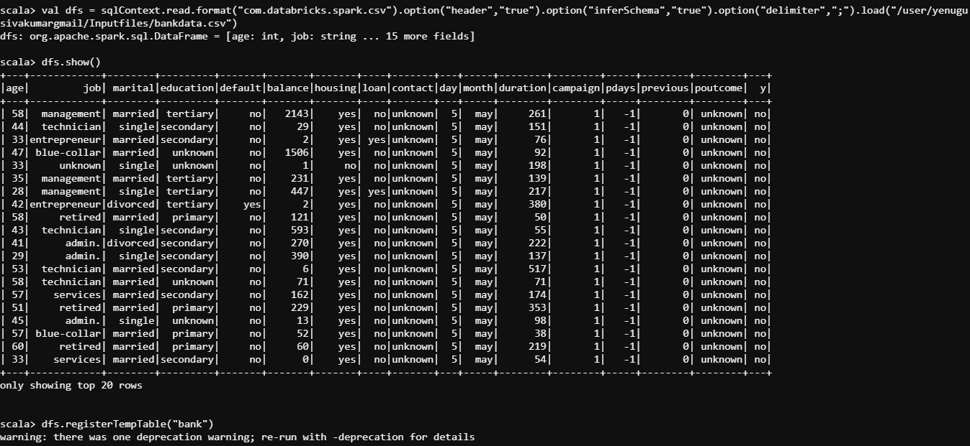

Data is loaded to a data frame. And dataframe is loaded to a bank table in spark.

1. Give marketing success rate (No. of people subscribed / total no. of entries)

* Give marketing failure rate

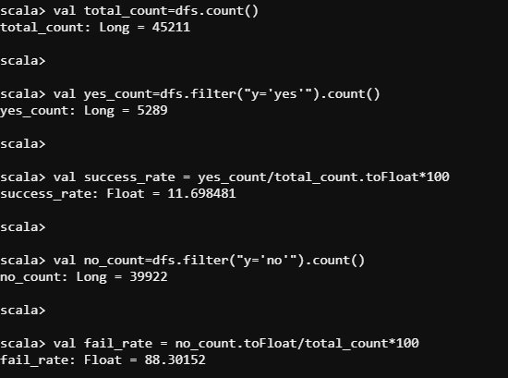

Success_rate of 11.69% gives marketing success rate and fail_rate of 88.30% gives marketing failure rate.

1. Give the maximum, mean, and minimum age of the average targeted customer

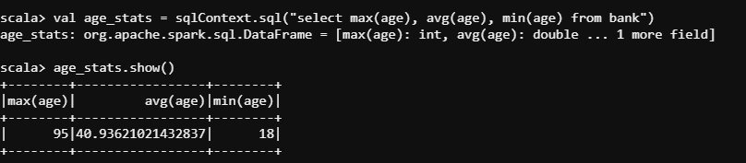

1. Check the quality of customers by checking average balance, median balance of customers

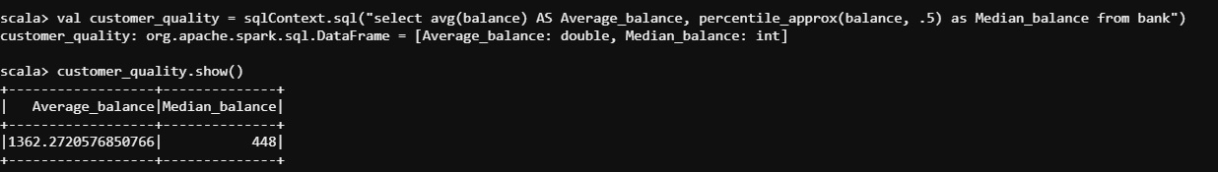

1. Check if age matters in marketing subscription for deposit

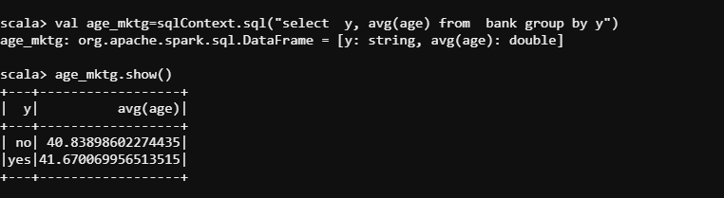

Approximately 40% of customers have deposit and 40% without deposit. Hence age matters in marketing subscription.

1. Check if marital status mattered for a subscription to deposit

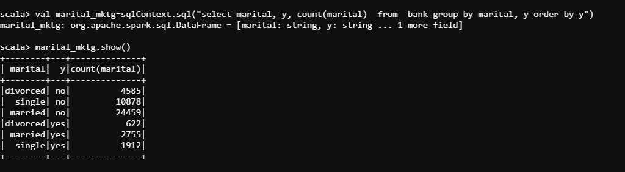

Of all customers who are married they have done most number of deposits and couples are followed by singles. Hence marital status also matters in marketing subscription.

1. Check if age and marital status together mattered for a subscription to deposit scheme

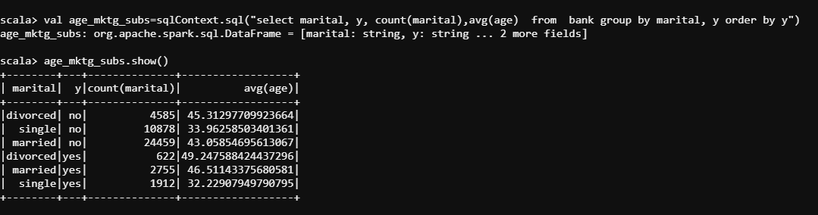

Customers who are married and ages are around 40-50 has most number of deposits. Hence, age and marital together mattered for a subscription to deposit scheme.

1. Do feature engineering for the bank and find the right age effect on the campaign

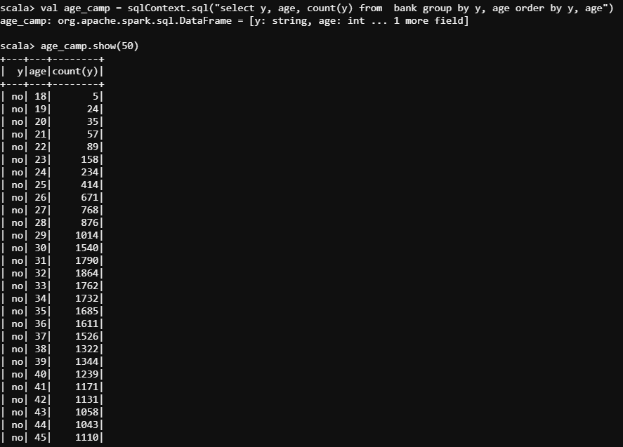

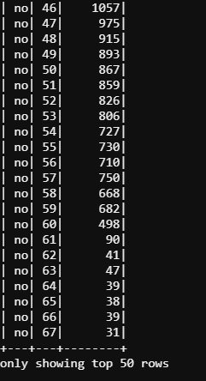

Here, we can see that customers with their ages from 30-45 has most number of term deposits.

Let’s group the ages into three for more understanding.

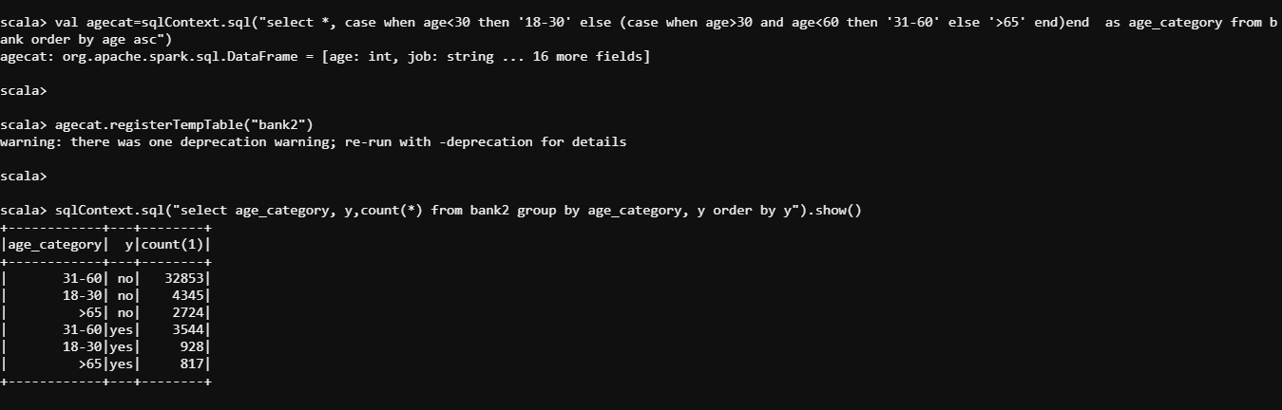

Hence, the customers ranging their ages from 31 to 60 have most number of deposits.